**Stamford University Bangladesh**

**Department of Computer Science & Engineering**



**Group name: Bit Legion**

**Online Shopping System**

**Software Engineering Sessional**

**CSI 332**

**Final Report**

**Submitted to: Submitted by:**

**Name: Ashfaq Ali Shafin Name:**

**Designation: Lecturer Shekh Raisul Islam**

**Tanjina Sharmin**

**Md. Juwel Islam**

**ID:**

**CSE06307450**

**CSE06307439**

**CSE06307460**

**Proposal**

**Introduction:**

Online shopping is the process whereby consumers directly buy goods or services from a seller in real-time, without an intermediary service, over the Internet. It is a form of electronic commerce. This project is an attempt to provide the advantages of online shopping to customers of a real shop. It helps buying the products in the shop anywhere through internet by using an android device. Thus the customer will get the service of online shopping and home delivery from his favorite shop.

**Goals:**

* To develop an easy to use web based interface where users can search for products , view a complete description of the products and order the products.
* The user can easily add a product to or remove a product from the shopping cart.
* An user can view the complete specification of the product along with various images and they can also write their own reviews.
* An admin can view the review or feedback of the user along with other details.

**Scope of Work**

**Page Templates**

* Design Templates ( No Cap on the number of revisions)
* User Visibility research and Layout Engineering
* Logos ( No Cap on the number of revisions)

**Template Layout**

**Banner**

•Size according to specifications

• Logo Placement

• Text

• Graphics

**User Visibility Content**

• Information bar

• Menu Bar

• Tool bar

• Side Bar

• Header and Footer

• Text and Graphics

**Design Specifications**

Design tools and technologies. The design and layout of the application will be SEO friendly constructed using CSS and XHTML, DHTML along with use of AJAX and keeping in mind the latest web 2.0 trends. The application upon completion will be integrated with Google analytics for keeping an eye on the statistics of the site. It will carry tell a friend and printer friendly version at all pages. To help peoplebookmark the site easily; add this widget will be embedded at the top of the homepage.

**Front End**

**The front end will have following features:-**

* Header Pages
* Footer Pages
* Website Content Page
* Customer Registration
* Existing Customer
* Function of Customers
* My Account Control Panel for Customers
* Search
* Advanced Search
* Products
* Products Catalog
* Products Information
* Customize
* Events
* Review
* Shopping Cart
* Check out
* Shipping
* Payment Gateway
* Social Media Integration
* Newsletter
* Contact Us
* FAQ

**Administrative Panel**

* Customers Management
* Product Management
* General Management
* Order Management
* Content Management
* Reports Management

**Delivery Schedule**

|  |  |
| --- | --- |
| weeks | Key Deliverables (Modules) |
| 2 | System Analysis . |
| 3 | Knowledge transfer, Working on the layout, Working on the functional requirements, Locking in the database design, Workings on Specific requirements and project review. |
| 2 | Development of module for customer’s registration, my account panel, search, advanced search with corresponding admin panel. |
| 2 | Development of module for products information, products catalogue, Customize, Events, shopping cart, and check out with corresponding admin panel. |
| 2 | Development of module for payment gateway integration, shipping gateway integration, reviews and with corresponding admin panel. |
| 2 | Development of module for social media integration, newsletter, static pages and contact us page with corresponding admin panel. |
| 5 | Exhaustive testing, Ensuring Browser compatibility, Final delivery. |

**Process Flow**

**Analysis**

**Design**

**Review**

**Implement**

**Testing**

**Project Delivery**

Our Methodology… Best quality with the best design

**Support**

**Gantt Chart:**

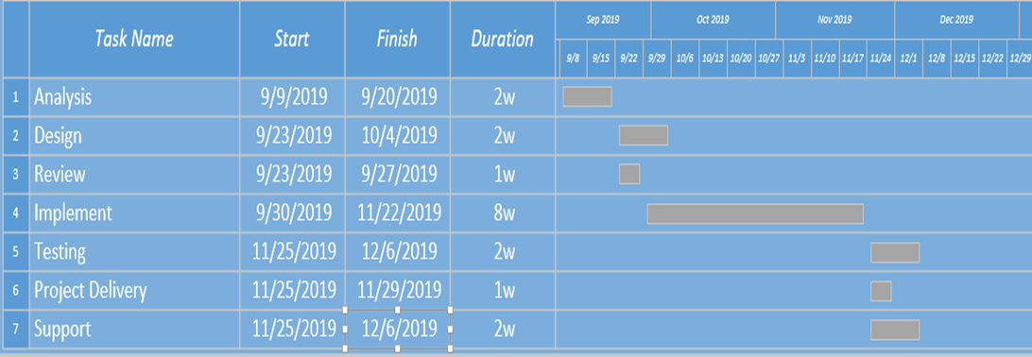

**Feasibilities:**

**Technical Feasibility:**

* Technology exists to develop a system.
* The proposed system is capable of proving adequate response and regardless of the number of users.
* The proposed system being modular to the administrator, if he/she wants can add more features in the future and as well as be able to expand the system.
* As far as the hardware and software is concerned, the proposed system is completely liable with proper backup and security.

**Operational Feasibility:**

* The proposed system will improve the total performance.
* Customers here are the most important part of the system and the proposed system will provide them with a convenient mode of operation for them.
* The proposed system will be available of the customers throughout the globe.
* The proposed system will provide a better market for different dealers.

**Economical Feasibility:**

* The cost of hardware and software is affordable.
* High increase of the amount of profit earned by going global.
* Easy and cheap maintenance of the system possible.
* Very cheap price for going global.

**Risks and Threats**

All this might make it sound as if your e-commerce business can’t possibly fail. Some risks are particularly relevant to e-commerce companies, such as:

1. Hacking
2. Credit card scams
3. Hardware failures
4. Unreliable shipping services
5. Software errors
6. Changing laws

**Conclusion:**

Online shopping is the process whereby consumers directly buy goods or services from a seller in real-time, without an intermediary service, over the Internet. It is a form of electronic commerce. An online shop, e-shop, e-store, internet shop, web-shop, web-store, online store, or virtual store evokes the physical analogy of buying products or services at a bricks-and-mortar retailer or in a shopping center. The process is called Business-to-Consumer online shopping. When a business buys from another business it is called Business-to-Business online shopping.

**Information Gathering**

**Introduction:**

We already work in our proposal now we have discuss about our information gathering for the project.

**Objective of project:**

* The main objective of the project is to help the ongoing user help to attain an easy way to get mobile in online shop.
* It is basically a very instant processing system by which customer can get the mobile in the right condition.
* The manager of the mobile store also finds it sufficient enough to view the details of the sales, servicing and well organized way to employ the staff that are included in the mobile store itself.

**Information gathering system:**

We chosen three system for information gathering:

* Interview
* Questionnaires
* Investigation

**Interview: (Client)**

We use funnel type for interview system.

The interview questions and answers are given below:

**Question 1: Describe your business in a few sentence?**

Answer: Actually we have a mobile shop. We import different kind of smart phone from china. Now we want to increase our business by a online mobile shop.

**Question2: What specific features do u want?**

Answer: Different Categories for the people of different gender, age and classes for various products. Must have a built in customer support chat application for continuous care.

**Question3: What are your goals for this project?**

Answer: To generate more sell and achieve customer satisfaction.

**Question4: Who is your target audience?**

Answer: Basically young people aged between 18-35 from metropolitan area in preliminary stage.

**Questin5: Who are your main competitors ?**

Answer: Actually running e-commerce sites who sell mobile phones.

**Question6: What will make you different from your competitors?**

Answer: Easy to use and order product.

**Question7: What is your expected time frame for total project completion?**

Answer: 3 months

**Questionnaires: (Users)**

We collect the questionnaires result from the social media .

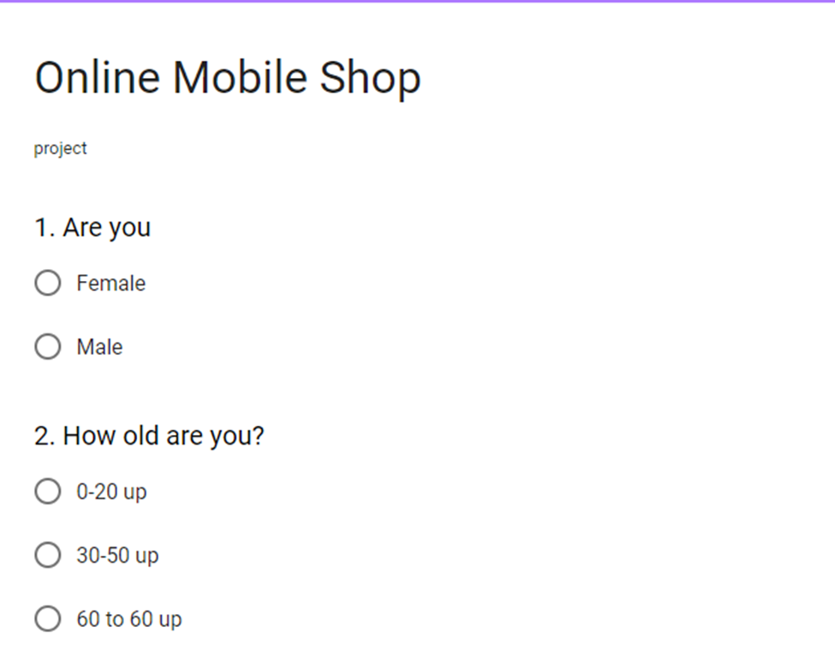

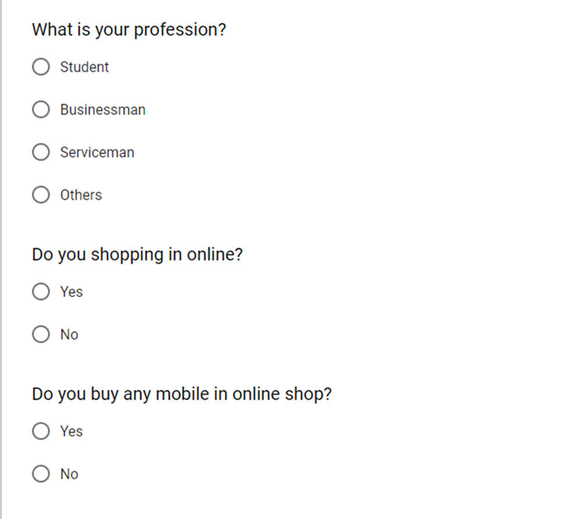

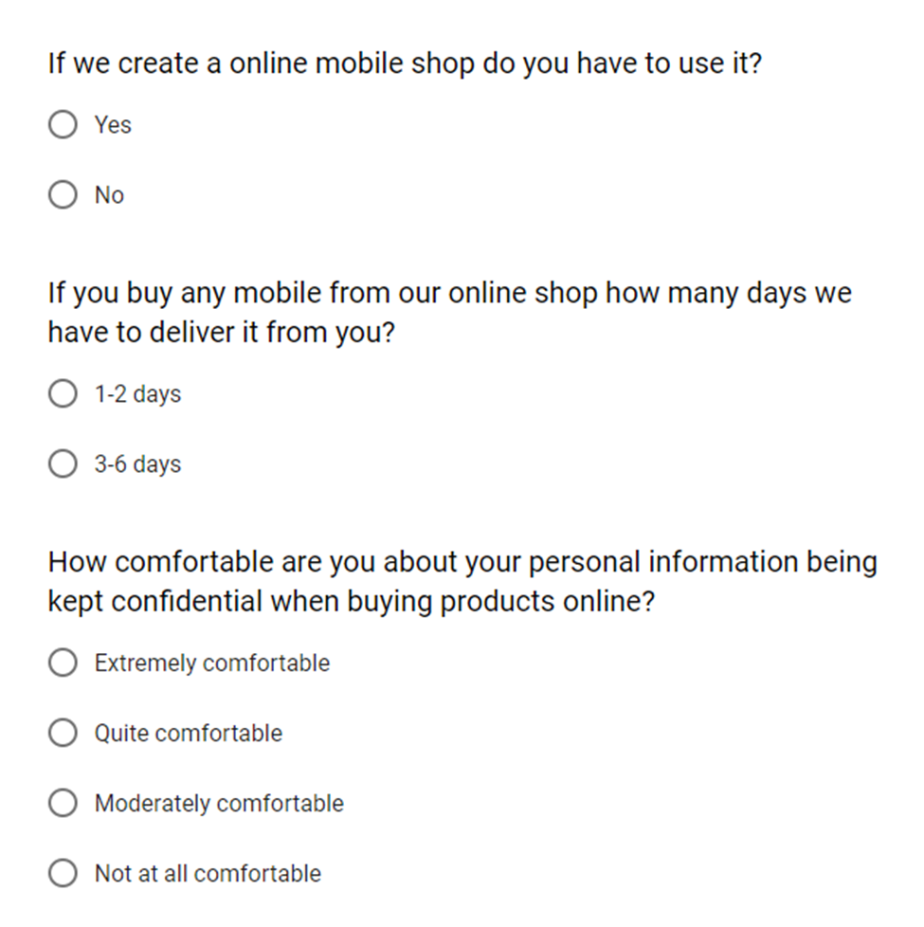

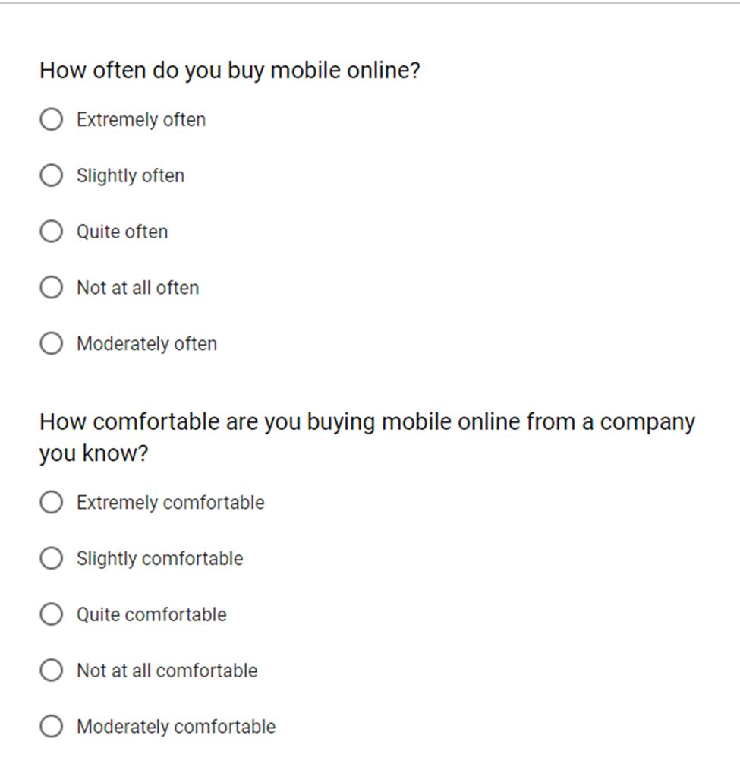

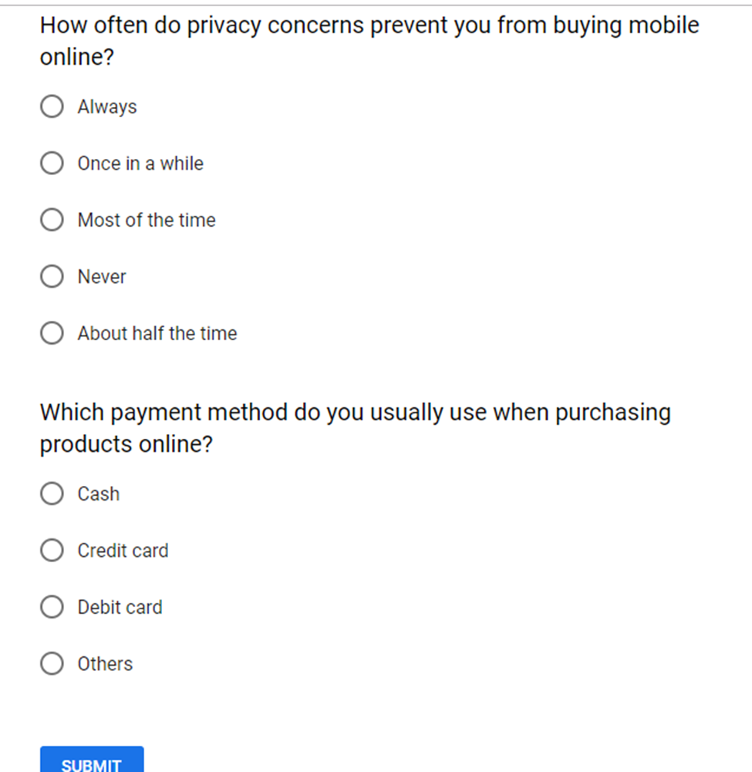

**Investigation:**

More than 140 million people, out of Bangladesh's population of 160 million, use mobile phones while around 80 million people access the internet, say the telecom regulators. According to current reports, at present 1.6 billion people use their mobile devices to shop online globally.

**Analysis:**

In our investigation, interview and questionnaires process we see that:

* Most of the people want to buy mobile phone from online mobile shop.
* Most of the people feel comfortable to buy mobile phone in online from a company they know.
* Most of the people like to payment in cash.
* Our client target is young generation in our analytics young generation is more inclined to buy mobile from online mobile shop.

**Conclusion:**

This report will make our project work easier. It also helps to make our web based software.

**Survey Result:**

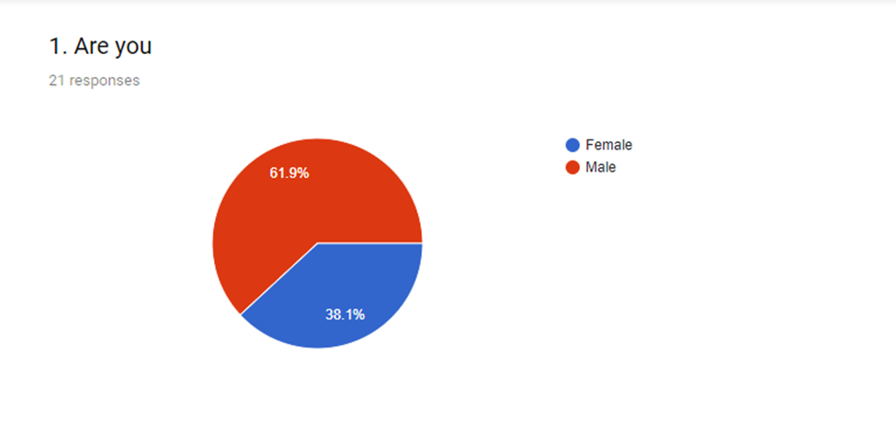

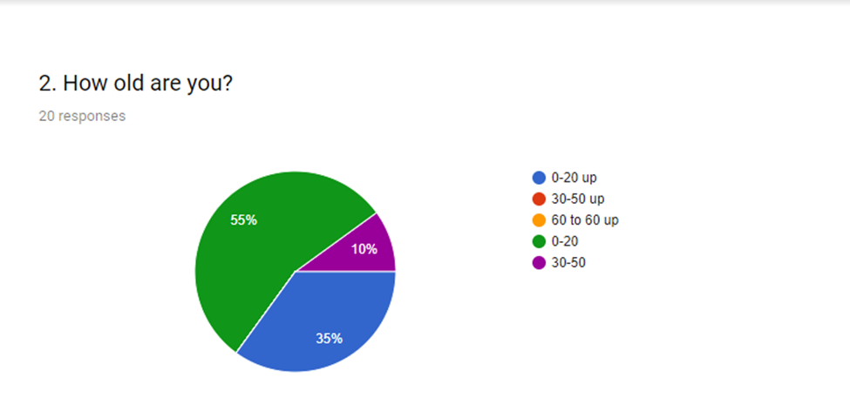

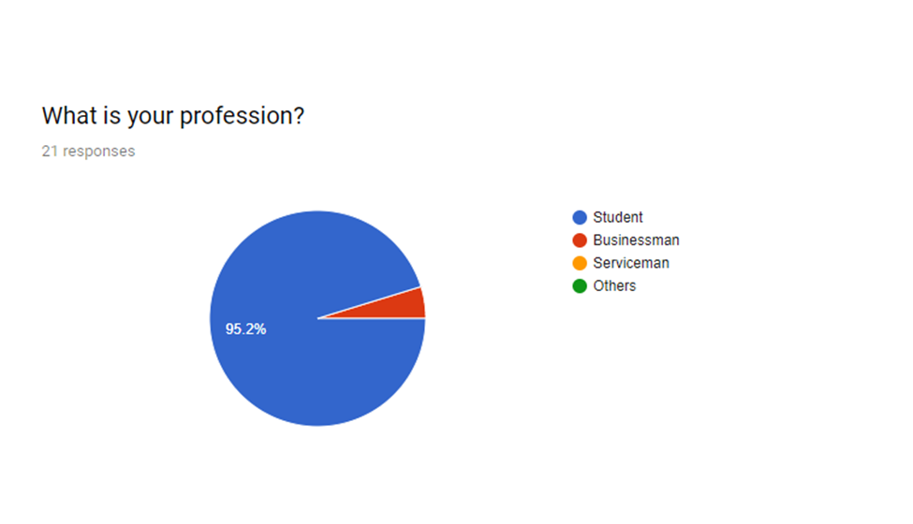

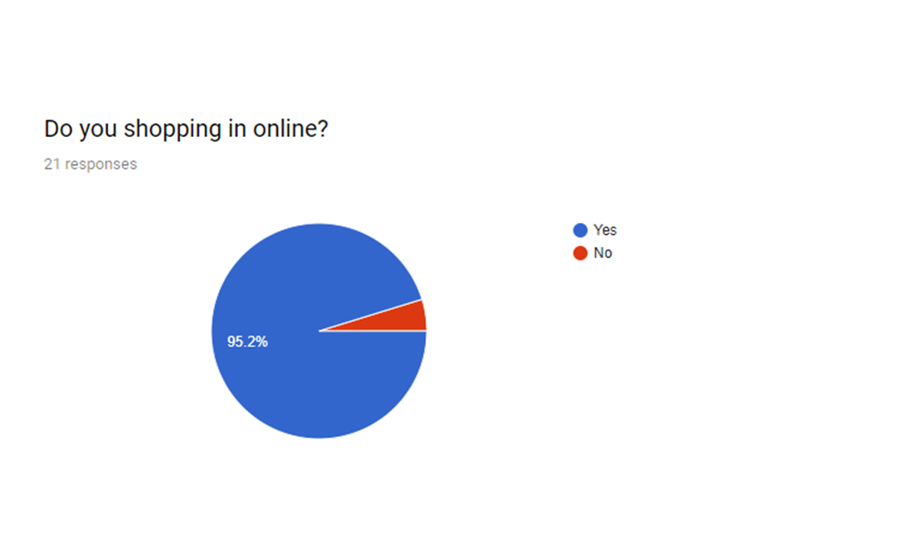

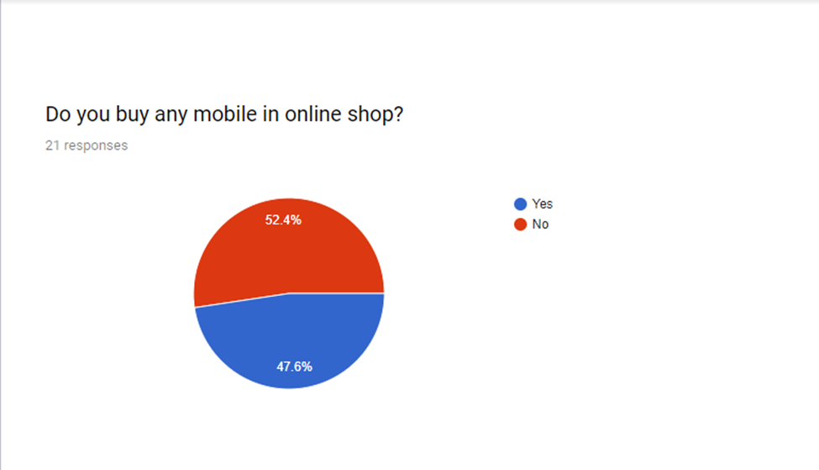

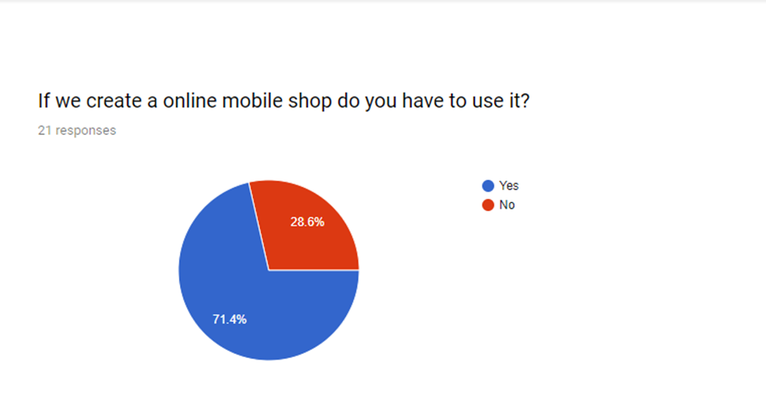

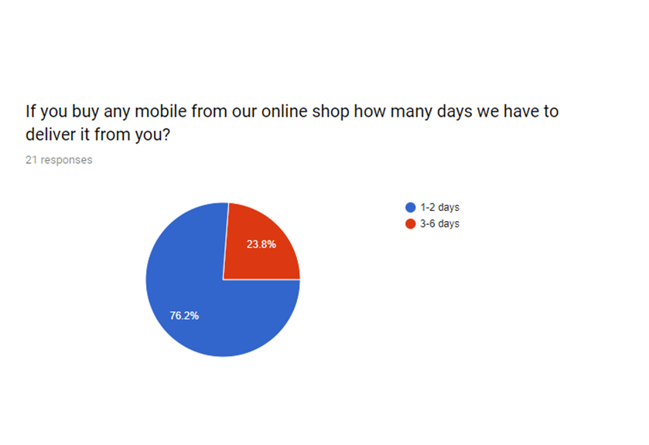

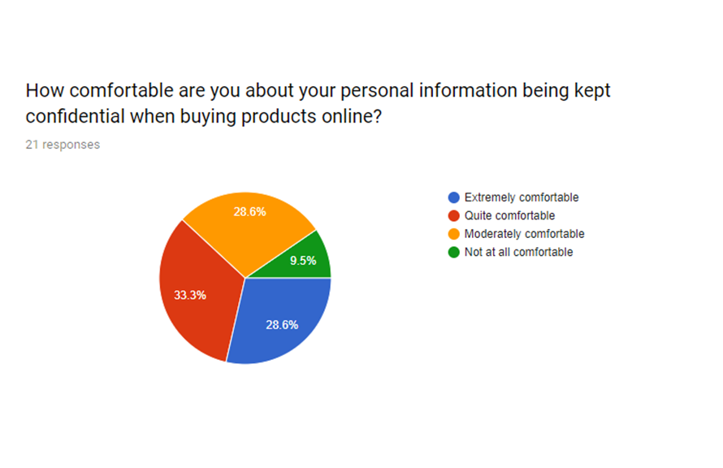

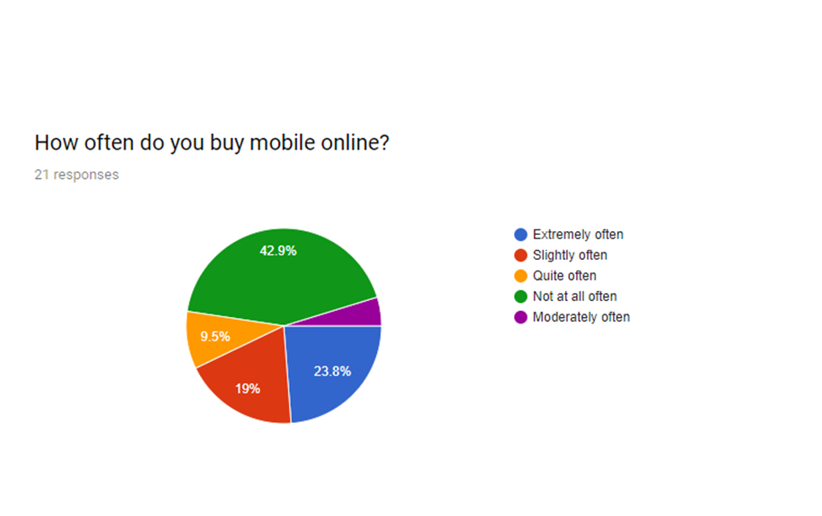

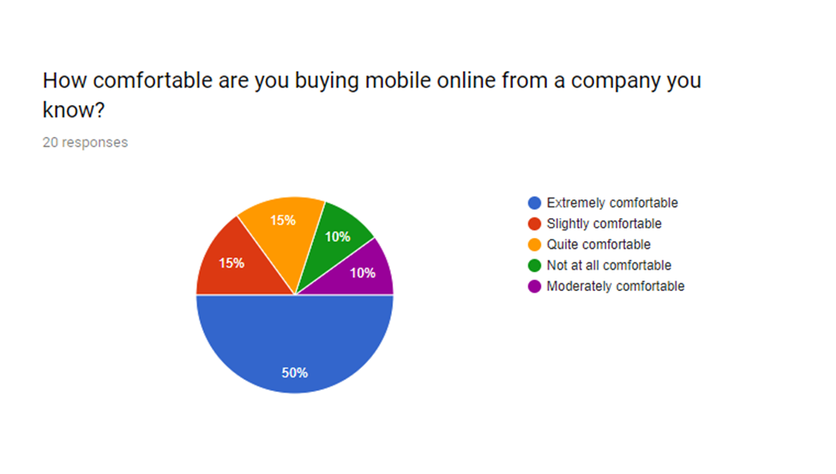

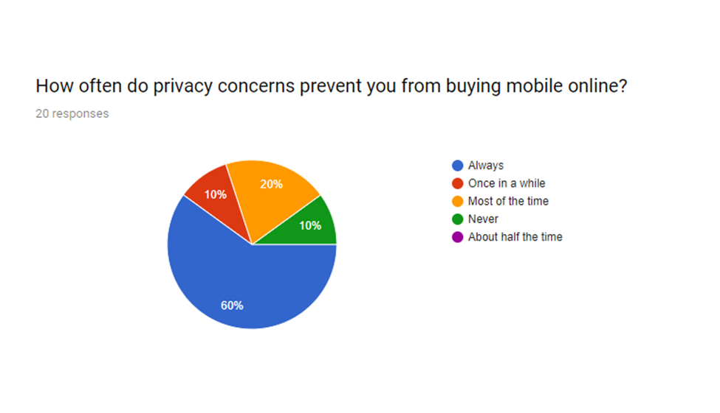

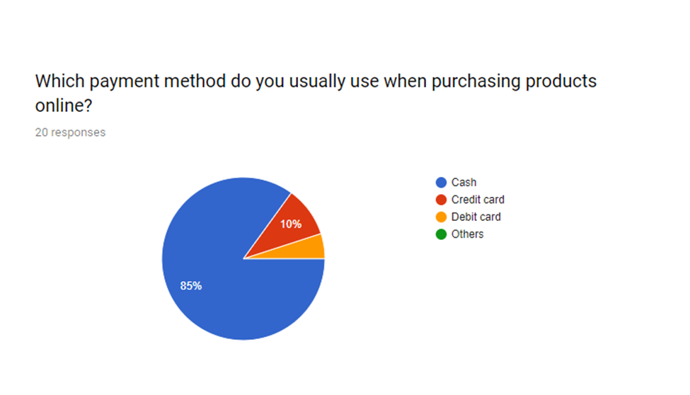

**Introduction:**

We already work in our information gathering system now in this report we will show our data flow diagram. Data flow diagram show that how we will work in our project.

|  |
| --- |
|  |

**Data Flow Diagram (DFD):**

**Activity list:**

**Sale Production Procurement Payroll**

User order and Employee see the Employee make order decision Employee worked

payment in sale production schedule from procurement project. in payroll project.

project. in production project. Admin purchase order from Payroll project

Production project procurement project. pay employee.

served product to user

**Main process:** Online Mobile Shop.

**Sub process:**  Sale, Production, Procurement, Payroll.

**Entity:** Admin, User, Employee.

**DFD-Context level**

0.0

**Online Mobile Shop**

**Employee**

**Admin**

Manage products

Manage orders

Manage users

Manage product

**User**

Manage user

Manage order

Manage employee

View product

Purchase product

Search product

Edit profile

**Context level**

**DFD-Level 0:**

**User**

**1.0**

**Sale**

Order

**3.0**

**Procurement**

**4.0**

**Payroll**

Payment

Product ordered Sales forecast

**2.0**

**Production**

Product served

Production schedule

Inventory

Received goods

**Admin**

Purchase order

Order decisions

Payment

**Employee**

Pay

Time worked

**DFD –Level 1:**  Check detail

**1.1**

**Login**

Request to login **UserMst**

**User**

Replay

Response

**1.2**

**Registration**

**UserMst**

Check detail

Replay

**1.3**

**Search item**

Request for view

Replay **ItemMst**

Request for view

**1.4**

**Account**

**UserMst**

Replay

**1.5**

**Buy item**

Request for

view **ItemMst**

Replay

Request for view

**1.6**

**Make order**

Replay **OrderMst**

**1.7**

**Make Payment**

Request for view

Request to login

**3.1**

**Login**

**Admin**

**min AdminMst**

**3.5 Payment report**

**3.4**

**Order report**

**3.3**

**Item report**

**3.2**

**User report**

Check detail

Response Replay

**UserMst**

Request for view

Replay

Request for view

**ItemMst**

Replay

Request for view

Replay **OrderMst**

Request for view

Replay

PaymentMst

Request to login

Check detail

**Employee**

**4.1**

**Login**

**4.2**

**Time worked**

**4.3**

**Order decisions**

**yee EmployeeMst**

Response

Replay

Request for view

**EmployeeMst**

Replay

Request for view

**OrderMst**

Replay

**Process Decomposing:**

**Context level Level 0 Level 1**

1.0 Sale 1.1 Login

1.2 Registration

1.3 Search item

1.4 Account

1.5 Buy order

1.6 Make order

1.7 Make payment

Online Mobile

Shop 2.0 Production

3.1Login

3.2 User report

3.0 Procurement 3.3 Item report

3.4 Order report

3.5 Payment report

4.0 Payroll 4.1 Login

4.2 Time worked

4.3 Order decision

**Conclusion:**

Data Flow Diagram will make our project easier and it also help in our project work.

**Database Tables, Attributes and Data type:**

|  |  |  |  |  |  |  |
| --- | --- | --- | --- | --- | --- | --- |
| |  |  |  | | --- | --- | --- | | **Table Name**  User  Login  Product | **Attribute**  us_id  us_name  email  address  phone_no  us_id  us_name  password  pro_id  pro_name  pro_desc  model_no  amount | **Data type**  Int(primary key)  Varchar(100)  Varchar(100)  Varchar(1000)  Int  Int(primary key)  Varchar(100)  Varchar(100)  Int(primary key)  Varchar(100)  Varchar(1000)  Varchar(100)  Int | | | | |
| Admin  Registration  Cart  Payment | ad_id  ad_name  reg_id  email  password  confirm_pass  pro_id  us_id  pro_name  pro_id,us_id  pay_id  card_num  card_ty  pay_desc  pay_date  pay_amt | Int(primary key)  Varchar(100)  Int(primary key)  Varchar(100)  Varchar(100)  Varchar(100)  Int(foreign key)  Int(foreign key)  Varchar(100)  Int(primary key)  Int(primary key)  Varchar(100)  Varchar(100)  Varchar(1000)  Int  Int | |

|  |  |  |  |  |  |  |  |  |  |  |  |  |
| --- | --- | --- | --- | --- | --- | --- | --- | --- | --- | --- | --- | --- |
| |  |  |  |  |  | | --- | --- | --- | --- | --- | | Admin  Registration  Cart  Payment | | ad_id  ad_name  reg_id  email  password  confirm_pass  pro_id  us_id  pro_name  pro_id,us_id  pay_id  card_num  card_ty  pay_desc  pay_date  pay_amt | | Int(primary key)  Varchar(100)  Int(primary key)  Varchar(100)  Varchar(100)  Varchar(100)  Int(foreign key)  Int(foreign key)  Varchar(100)  Int(primary key)  Int(primary key)  Varchar(100)  Varchar(100)  Varchar(1000)  Int  Int | | Confirmation order | | us_id  pro_name  phone_no  tax  amount  total | | Int(primary key)  Varchar(100)  Int  Int  Int  Int | | | |

**ER-Diagram**

**Take**

**Take**

**Maintains**

**Make payment**

**Add**

**Site view**

**Verify**

**Payment**

**Confirmation order**

**Confirm**

**Cart**

**Admin**

**Product**

**Registration**

**Login**

**User**

**Work Distribution:**

**Shekh Raisul Islam : 36 %**

**CSE06307450**

**Tanjina Sharmin : 31 %**

**CSE06307439**

**Md . Juwel Islam: 33%**

**CSE06307460**